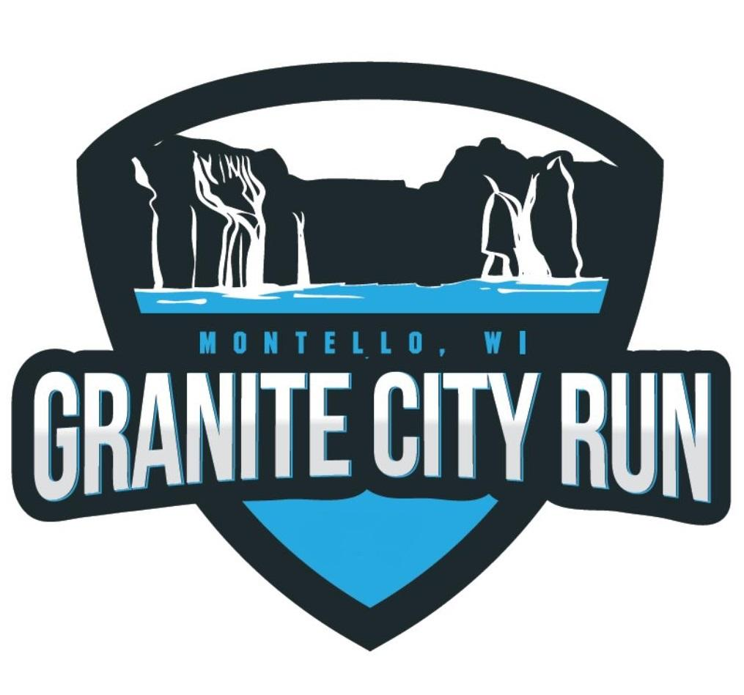
October 2, 2021
7:30 a.m. Registration/Packet Pick-up Begins 9:00 a.m. Event Start
Montello City Park, Montello, WI

REGISTRATION FORM

First name: Birthdate: ________ Sex: M / F

Last name: ZiP

Shirt: S M L XL YOUTH S M L

Event (Circle One): 5K Walk 5K Run 10K (9:30 start time) ** $30.00 for each entry

1 Mile Kid’s Run ($5.00 entry fee for each) ¼ Mile Kids Run ($5.00 entry fee for each)

Street Address:

City State

E-mail address :

Phone Number: - -

Where did you hear about the race? ____ Website ____ Facebook ____ Email ____ From a Friend ____ Other

Who is an emergency contact for you? NAME__________________ Telephone Number __________________

In consideration of accepting this entry, I hereby waive and release any and all rights and claims for damages I may have against Montello Rotary Club, Race Day Events, LLC, City of Montello, the race committee, sponsors, volunteers and representatives, for any and all injuries to me in this event. I attest and verify that I am physically fit and have sufficiently trained for the completion of this event and my physical condition has been verified by a licensed medical doctor. I recognize and accept the inherent dangers of running or walking in an event such as the Granite City Run including but not limited to changing weather conditions, natural obstacles such as trees and rocks, collisions with traffic, and the possibility of severe injury resulting from a fall. I understand and agree that this Waiver and Release is binding. Further, I hereby grant full permission to any and all of the foregoing to use any photographs, motion pictures, recordings, or any other record of this event for any legitimate purpose, including commercial advertising.

Signature: _____________________________________________ Date: ___________

Parent or guardian (if under 18): __________________________________ Bib #________ (Race use only)

